How to Add Arrow Indicator in Power BI
Step 1: Create two “Measure”
- “Formatted Indicator”
- “Formatted Color”

Step 2: Formatted Indicator
Now, let’s add a dynamic touch to your KPIs. The DAX formula for “Formatted Indicator” looks like this:
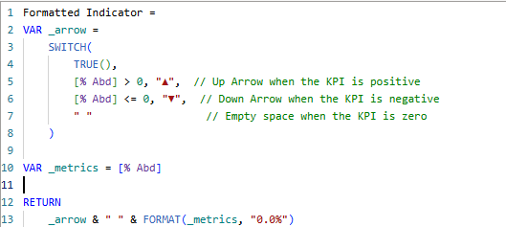

Step 3: Formatted Color
To further enhance your KPI visuals, we’ll incorporate custom color-coding. Use this DAX formula for the “Formatted Color” measure:
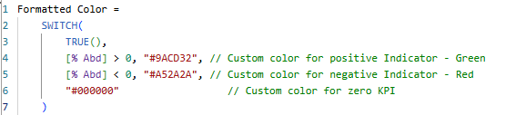
Step 4: Here where MAGIC happens!
Once you’ve created these measures, it’s time to bring your indicators to life.
Drag the “Formatted Indicator” measure into your card visual, and you’ll see Indicators’ with up and down arrows.

